CHAPTER THREE
SYSTEM ANALYSIS, DESIGN AND METHODOLOGY
3.1 Introduction
Having established in Chapter One the background, problem statement, and objectives of the Hostel Asset and Property Management System (HAPMS) and having reviewed in Chapter Two, the body of literature relating to physical asset management and digital property management systems, this chapter turns from why the system is needed to how it was analysed, designed, and structured. System analysis and design is the stage of the software development lifecycle at which the loosely stated needs of an organisation are translated into a precise, buildable specification: the existing way of working is examined in detail, its shortcomings are made explicit, and a new system is defined that resolves those shortcomings within a concrete technical architecture.
Section 3.3 presents the development methodology. Sections 3.4–3.6 analyse the existing manual system, its problems, and the case for a new one. Section 3.7 analyses the proposed system's objectives, features, and benefits. Section 3.8 states hardware and software requirements; 3.9 and 3.10 specify functional and non-functional requirements. Section 3.11 covers system design and architecture; 3.12 covers database design; 3.13 and 3.14 cover input and output design; and 3.15 presents the discrepancy flagging algorithm central to Session End Verification.

3.2 Software Development Methodology
A software development methodology is the structured process by which a system moves from a statement of requirements to a working, tested product; it prescribes the order in which analysis, design, implementation, and testing activities occur, and how the project responds when a requirement changes or a defect is discovered (Sommerville, 2016). Several methodologies were considered for this project before a final choice was made. The Waterfall Model, in which each phase (requirements, design, implementation, testing, deployment) is completed in full before the next begins, was set aside because it assumes requirements are completely known and stable in advance, and because it produces no working system until the very end of the project, which would have left little room to test the sign-off and verification workflow the very core of the system's value until the whole system was already built. The Spiral Model, which wraps a Waterfall-like sequence in repeated risk-analysis cycles, was judged to add process overhead that a single-developer academic project of this scope did not need. The Prototype Model in which a throwaway prototype is built purely to clarify requirements before the real system is developed, was also set aside, since the Business Requirements Document and Technical Requirements Document produced ahead of implementation already served that clarifying purpose without requiring a disposable build.
The Incremental Model was ultimately adopted (Sommerville, 2016). In this model, the system is not built as a single unit. Instead, it is developed and delivered in a series of increments. Each increment carries a complete slice of functionality through its own requirements refinement, design, implementation, and testing, arriving at a working state before the next increment begins. Because each increment builds directly on a foundation that has already been implemented and exercised, a usable, testable version of the system exists from an early point in the project. Defects discovered in a later increment can very often be traced back to a specific, small unit of newly added functionality, rather than to the system as an undifferentiated whole.
This methodology was chosen specifically because the requirements of HAPMS are naturally organised around logically dependent capabilities rather than around a fixed calendar schedule of weeks or sprints. The data layer and the authentication system had to exist before Administrator configuration was possible; Administrator configuration, in turn, had to exist before a Porter could record a Room Inventory Baseline against a room that had first been created; and a recorded baseline had to exist before a Student could sign off on it, or before a Porter could later perform Session-End Verification against it. Sequencing the build by this dependency order, rather than by fixed time-boxed sprints as in a conventional Agile/Scrum process, made the Incremental Model a more natural fit for this project than either Agile or Waterfall in their textbook forms, while still preserving Agile's central advantage the early and continuous availability of working, demonstrable functionality over a strict Waterfall delivery.

Phases of the Incremental Model Adopted
Guided by this dependency ordering, the system was developed across twelve increments, each described below with the capability it added.
Increment 1
Foundations and Data Layer : Established the backend/frontend scaffolding, the MySQL connection, and the full relational schema (users, halls, rooms, sessions, baselines and their items, sign-offs, condition reports, verification records and their items, and the audit log) that every later increment depended on.
Increment 2
Authentication and Access Control: Implemented JSON Web Token (JWT)-based login and a single, reusable role-based access control dependency applied to every protected route, so later increments inherited consistent security rather than ad hoc checks.
Increment 3
Administrator Configuration: Delivered the Administrator's ability to create halls, rooms, accounts, Porter to room assignments, and sessions a hard prerequisite for every role-specific increment that followed.
Increment 4
Porter Baseline Entry : Implemented the category-filtered Baseline Entry Form, restricting a Porter to only the asset types valid for a room's hall category.
Increment 5
Student Onboarding and Room View : Implemented the manual Kofa bridge and the Student's read-only room view, split into corner and shared-room groupings.
Increment 6
Student Sign-off and Dispute Handling : Delivered independent corner- and shared-level sign-off, with an optional dispute comment attached to a contested sign-off.
Increment 7
Condition Reports and History : Added the Student's optional condition report and a read-only history of past allocations, sign-offs, and reports.
Increment 8
Session-End Verification and Locking: Implemented the Porter's verification screen, the automated discrepancy-flagging algorithm described in Section 3.14 and the record-locking rule that follows it.
Increment 9
Administrator Reporting and Audit Trail : Delivered the dashboard summary, baseline/verification report listings, and the chronological audit trail.
Increment 10
Pending-Action Indicators (conditional) : Where time allowed, added derived, login-time indicators of outstanding actions, such as an unsigned baseline or an unverified room, consistent with the BRD's treatment of this feature as a stretch goal rather than a core requirement.
Increment 11
Cross-Role Hardening: A systematic audit of role-based data scoping, session-lifecycle edge cases, input validation, and a walkthrough of the Business Requirements Document's acceptance criteria.
Increment 12
Delivery: Environment configuration, deployment, and preparation of project documentation, including this report.

Advantages of the Incremental Model
In the specific context of this project, the Incremental Model offered the following advantages over the alternative methodologies considered above (Sommerville, 2016):
- A working version of the system existed from an early stage by the end of Increment 4, a Porter could already record a real baseline rather than only at the very end of the project, as under a strict Waterfall approach.

- Each increment was small and functionally self-contained, so it could be tested and debugged largely in isolation, making defects easier to locate than in a single system assembled all at once.

- An error discovered in one increment could be corrected without destabilising work already completed in earlier increments, reducing the overall risk carried by the project.
- Requirements could be, and were, refined between increments for instance the asset composition of the TETFUND and Daisy Danjuma halls, and Hall 7’s corner labelling through ongoing stakeholder conversation, rather than frozen at a single session at the project’s start.

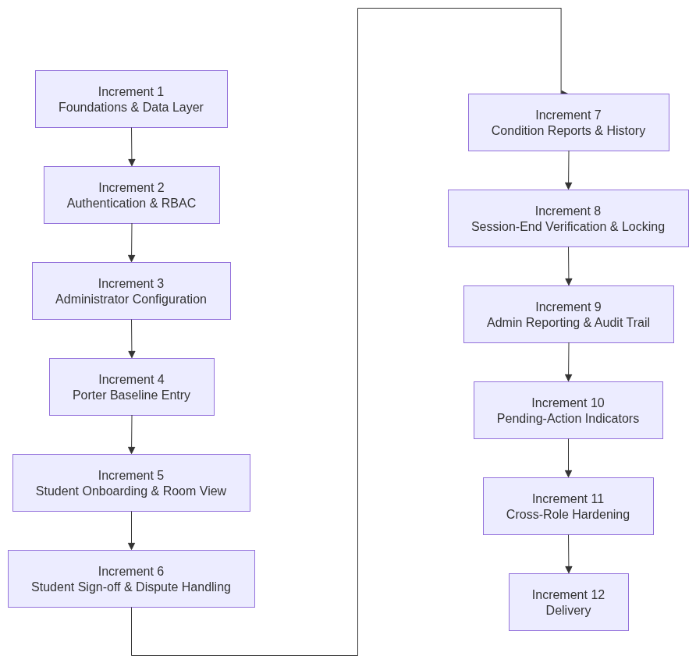
Figure 3.1: Incremental Development Model Phases

3.3 Analysis of the Existing System
The University of Benin manages a large number of student hostel facilities, which house thousands of students across each academic session. These facilities are broadly categorised into Regular Halls (Halls 1 to 4), which provide basic bunk accommodation to as many as eight occupants per room, and Special Halls (Hall 5, Hall 6, Hall 7, TETFUND Halls A to D, and Daisy Danjuma Hostel), which house smaller numbers of occupants per room and are furnished with a broader inventory of individually assigned assets, including mattresses, tables, and chairs, in addition to the shared items common to both categories, such as cupboards, window blinds, and fans.
At the beginning of each academic session, students are allocated to hostel rooms through the University's existing Kofa allocation process, which operates independently of any asset-tracking system. Once a student's room allocation is known, the hostel porter responsible for that room is, in principle, expected to be aware of what assets the room contains; in practice, however, this awareness exists only informally, in the porter's own memory and in whatever unstructured notes the porter may or may not choose to keep. No system, digital or otherwise, requires the porter to produce a fixed, dated, and attributable record of a room's contents before a student occupies it.
The same absence of structure characterises the end of a session. When a student vacates a room, there is no formal process by which the porter compares the room's current contents against what was originally present. Where any comparison happens at all, it is carried out from memory, or against informal notes of uncertain reliability, and its outcome if recorded at all takes the form of an entry in a manual register rather than a structured record linked to a specific student, room, and session. Because these registers are handwritten, kept in a single physical location, and not cross-referenced against any earlier baseline, they are highly susceptible to loss, damage, illegibility, and in the worst case deliberate alteration, and they provide no reliable basis on which hostel administration can determine, with confidence, when a particular asset went missing or which occupant was responsible.

3.4 Problems Identified
A close analysis of the existing manual approach to hostel asset management, described in Section 3.3 revealed the following specific problems, each of which the proposed system was designed to directly address.
Absence of a documented baseline: No formal, dated record exists of a room’s assets, or their condition, at the point of allocation leaving no reference point for later comparison.
Absence of systematic end-of-session verification: No structured process confirms asset state when a student vacates a room; where verification happens at all, it is informal and undocumented.
Unreliable, manual record-keeping : Paper-based registers and verbal agreements between students and porters are prone to loss, inconsistency, and manipulation.
No mechanism for individual accountability : With no baseline tied to a specific occupant, administration has no basis for attributing a missing or damaged asset to a particular student.
Exposure of incoming students to unwarranted liability. : A student who inherits an already-short room has no documentation proving the shortfall predates their occupancy.
Absence of institution-wide reporting : With no centralised digital record, administrators cannot generate aggregated reports across halls, sessions, or asset types.
Absence of an audit trail : No record exists of who performed which action and when, making it impossible to reconstruct what happened to a room’s assets.
Progressive, unchecked loss of assets: As a result, hostel inventories mattresses especially have declined steadily each session, at a recurring, avoidable cost to the University.

3.5 Justification for the New System
The problems identified in Section 3.4 stem not from any individual failing on the part of porters or administrators, but from the structural absence of a system to capture and later retrieve the information those actors need to act accountably. A formal asset management system replaces ad hoc observation with a repeatable lifecycle: a baseline recorded before occupancy, reviewed and signed off by the occupant, and used unchanged as the point of comparison when the room is vacated. This resolves the informational imbalance described in Chapter One a student can no longer be blamed for a deficit they cannot disprove, nor escape accountability for damage no record exists to catch by tying every asset record to a specific room, session, and occupant, with an automatic, tamper-resistant timestamp and attribution.
Existing commercial platforms were considered and found unsuitable. IT asset trackers such as Snipe-IT are built around individually serial-numbered equipment assigned to one custodian indefinitely, not a session-based, shared-room occupancy that changes every year. Hospitality platforms such as Hotelogix are built around nightly bookings and billing, not free, institutionally allocated occupancy. Neither offers the combination this project needs: a session-based cycle, a three-tier accountability chain, and university-hostel-specific reporting which justifies a purpose-built system over adapting an existing one.

3.6 Analysis of the Proposed System
In direct response to the problems identified in Section 3.4 and the justification set out in Section 3.5, the proposed system was analysed in terms of the objectives it must achieve, the concrete features it must provide in order to achieve them, and the benefits expected to follow once it is in use.
Objectives
- Give the Administrator centralised configuration of halls, rooms, accounts, Porter assignments, and sessions, so every other part of the system operates against one authoritative source of configuration data.
- Let a Porter record a Room Inventory Baseline restricted to only the asset types valid for a room’s hall category.
- Let a Student review their room’s baseline and independently sign off on its corner- and shared-room-level items, with an optional dispute comment.
- Let a Porter perform Session-End Verification, automatically comparing current state to baseline and flagging discrepancies without manual comparison.
- Give the Administrator visibility into system-wide asset status through summary reports and a full audit trail.
Features
- Administrator manages hostels, rooms, accounts, and Porter-room assignments
- Single login page with automatic role-based redirection; no public self-registration.
- A hall/asset rule engine determining which asset types and quantities apply to each room.
- Category-filtered Baseline Entry Form for Porters.
- Independent corner- and shared-group sign-off for Students, with an attached dispute comment.
- An optional student condition report submittable at any point before vacating.
- An automated Session-End Verification algorithm classifying each asset as ok, missing, damaged, or quantity-mismatched
- Automatic record locking once a baseline is verified.
- Administrator summary reporting and a full, reverse-chronological audit trail.

Expected Benefits
- Ties every asset to a documented baseline and a specific, named occupant of record for the first time, where the current process assigns responsibility to no one — the basis for a measurable reduction in unaccounted-for hostel asset loss.
- Protection for students against liability for pre-existing damage or shortages, via a signed, timestamped check-in record.
- Replaces a multi-step manual cross-check against paper registers with a single automated Session-End Verification per room, detecting discrepancies faster and more systematically than manual comparison allows.
- Surfaces discrepancies at the moment a session ends, rather than weeks later when the next occupant discovers a shortfall — closing a gap that currently has no time limit at all.
- An institutional audit trail supporting maintenance planning, procurement decisions, and future policy review — none of which is possible under the existing manual approach.

3.7 System Requirements

Hardware Requirements (Development)
Component | Requirement
Processor | Intel Core i5 or equivalent and above.
RAM | Minimum 8 GB; 16 GB recommended.
Storage | Minimum 256 GB SSD.
Internet | Stable internet connection.

Hardware Requirements (End User)
- An internet-enabled computer, laptop, tablet or smartphone capable of running a modern web browser.
- A stable internet connection.

Software Requirements (Development)
Software | Purpose
Windows 10/11, macOS or Linux | Operating system.
Visual Studio Code | Code editor.
Node.js, Next.js, TypeScript and Tailwind CSS | Frontend development.
Python 3.12 and FastAPI | Backend development.
SQLAlchemy | Object-relational mapping.
MySQL 8.4 | Relational database.
Git | Version control.
Docker/Podman with Compose | Local containerisation.
Google Chrome or another modern browser | Frontend testing.

Software Requirements (Deployment)
The deployed system requires a FastAPI application server, MySQL database and Next.js frontend served over HTTPS. End users only require a modern web browser and internet connection.

3.8 Functional Requirements
Functional requirements describe what the system must do, the specific actions and outputs it must provide to each class of user (Sommerville, 2016). The functional requirements of HAPMS, derived directly from the project's Business Requirements Document, are presented below, grouped by the user role to which they primarily apply.
Login and Account Management
- The system shall provide a single, shared login page for all user roles, and shall redirect the user, on successful authentication, to the dashboard appropriate to their role.
- The system shall restrict the creation of Porter and Student accounts to the Administrator; there shall be no public self-registration for any role.
- The system shall allow an Administrator to trigger a password reset for any user account, generating a temporary password to be relayed to that user.
Administrator Functions
- The system shall allow the Administrator to create and view hostel halls and the rooms within them.
- The system shall allow the Administrator to create, view, and deactivate Porter and Student user accounts.
- The system shall allow the Administrator to assign a Porter to one or more specific rooms.
- The system shall allow the Administrator to create a new hostel session and to close an existing session, subject to every room under that session having first completed Session-End Verification.
- The system shall present the Administrator with a dashboard summarising the total number of rooms on record and the total number of currently flagged asset issues.
- The system shall allow the Administrator to view baseline and verification report listings, and a full, chronological audit trail of every action taken across the system.
Porter Functions
- The system shall present a Porter with a list restricted to only the rooms that Porter is personally assigned to, never the rooms of any other Porter.
- The system shall allow a Porter to record a Room Inventory Baseline for an assigned room, restricting the available asset types to only those valid for that room's hall category.
- The system shall allow a Porter to perform Session-End Verification for a room, capturing the current quantity and condition of every item recorded in that room's baseline.
- The system shall allow a Porter to view the sign-off status of a room's baseline, including the text of any dispute comment recorded by an occupant.
Student Functions
- The system shall prompt a Student, on first login, to select the room and hall that the University's Kofa process allocated to them.
- The system shall present a Student with the assets recorded for their own room, split into the "My Corner" and "Shared Room Items" groupings described in Chapter One.
- The system shall allow a Student to independently sign off on the corner-level and shared-room-level groupings of their room's baseline, and shall allow a dispute comment to be attached to a contested sign-off.
- The system shall allow a Student to submit an optional condition report at any point before vacating their room.
- The system shall allow a Student to view a read-only history of their own past session allocations, sign-offs, and condition reports.
3.9 Non-functional Requirements
Non-functional requirements describe the qualities the system must exhibit in the course of meeting its functional requirements, rather than any specific action it must perform, and are commonly organised around the quality characteristics defined in the ISO/IEC 25010 software product quality model (ISO/IEC, 2011). The non-functional requirements of HAPMS are presented below.
Attribute | Description
Security | Passwords are stored as bcrypt hashes and never logged in plain text. Every protected route requires a valid JWT and passes through a single, centrally enforced role-based access control check.
Reliability | A verified baseline and its sign-offs are automatically locked and read-only. Every record is timestamped and attributed to its user automatically, with no manual date entry.
Usability | Each role is presented with a dedicated dashboard surfacing only the information and actions relevant to it.
Performance | A lightweight, decoupled REST architecture exchanges only the JSON a given screen needs, keeping response times fast at expected data volumes.
Maintainability | Frontend and backend are fully decoupled, communicating only through a defined JSON REST API, so either layer can be modified or redeployed independently.
Scalability | Stateless JWT authentication requires no server-side session storage, so additional backend instances can be added without changing how identity is verified.
Availability | The system is designed to remain accessible through an internet-connected device whenever the application server and network connection are available.

3.10 System Design
This section presents the overall design of HAPMS, moving from its high-level architecture through the standard set of behavioural and structural views used in software system design: use case, activity, sequence, class, entity-relationship, flowchart, and data-flow representations. Each subsection describes, in prose, the content and purpose of the corresponding diagram; the diagrams themselves are indicated with figure placeholders and will be inserted subsequently.
Architecture
HAPMS uses a decoupled, three-tier client-server architecture, chosen specifically so that the browser-facing presentation layer and the server-side business logic could be developed, tested, and reasoned about independently of one another. The presentation tier is a Next.js/TypeScript single-page application rendered in the user's browser, responsible for presenting each role's dashboard and forms and for making requests to the backend on the user's behalf. The application tier is a FastAPI (Python) REST API, responsible for authentication, role-based access control, and every item of business logic described in this chapter — asset-rule filtering, sign-off handling, the Session-End Verification flagging algorithm, and record locking among them. The data tier is a MySQL relational database, accessed exclusively through the SQLAlchemy Object-Relational Mapper rather than through hand-written SQL embedded in the application code. The presentation and application tiers communicate exclusively over HTTPS using JSON, and every request other than the initial login call is authenticated by a Bearer JWT attached to that request.
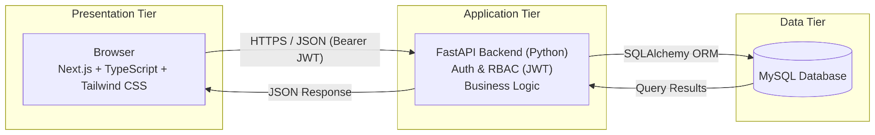Figure 3.2: Three- tier System Architecture
Use Case Diagram and Description
The use case diagram summarises, at a glance, the interactions each of the system's three actors — Administrator, Porter, and Student — may have with the system. Table 3.1 below expands each use case shown on that diagram with a short description of what it entails.
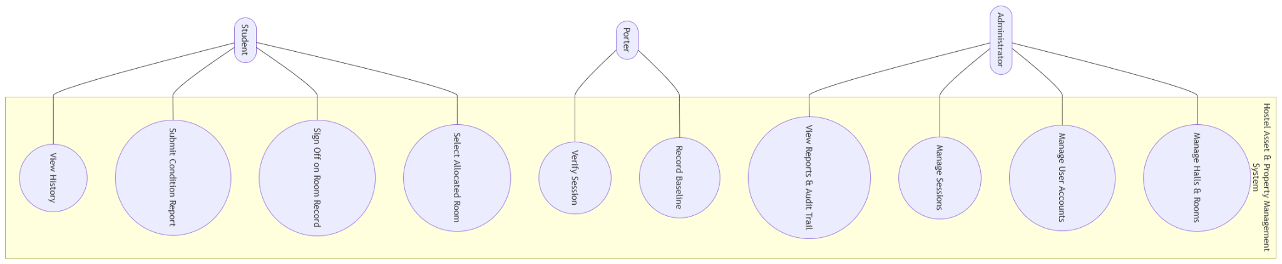Figure 3.3: Use Case Diagram for HAPMS
Actor | Use Case | Description
Administrator | Manage halls and rooms | Create and view hostel halls and rooms, and the asset rules that determine which asset types apply to each.
Administrator | Manage user accounts | Create, view, and deactivate Porter and Student accounts, and trigger password resets on their behalf.
Administrator | Manage sessions | Open a new hostel session, and close an existing session once every room under it has completed Session-End Verification.
Administrator | View reports and audit trail | View baseline and verification report listings, together with the system-wide, chronological audit trail.
Porter | Record baseline | Record the Room Inventory Baseline for an assigned room before a new student moves in.
Porter | Verify session | Compare a room's current state against its baseline at the end of a session, and review the discrepancies the system flags automatically.
Student | Select allocated room | Enter the room and hall allocated by the University's Kofa process, on first login.
Student | Sign off on room record | Independently confirm or contest the corner and shared-item groupings of the room's baseline, with an optional dispute comment.
Student | Submit condition report | Report a change in asset condition at any point before vacating the room.
Student | View history | View a read-only record of past session allocations and sign-offs.

Activity Diagram
The activity diagram traces the lifecycle of a single hostel room across the course of one session, from creation through to record locking. That lifecycle begins with the Administrator creating the hall and room and opening a hostel session; continues with the Porter recording the Room Inventory Baseline for that room; proceeds as the student is allocated the room through Kofa and, on the system, reviews and signs off on the recorded baseline, optionally attaching a dispute comment where the record is contested, and optionally submitting a condition report at any later point during occupancy; and concludes, at the end of the session, with the Porter performing Session-End Verification, after which the baseline and its associated sign-offs are automatically locked and become read-only.
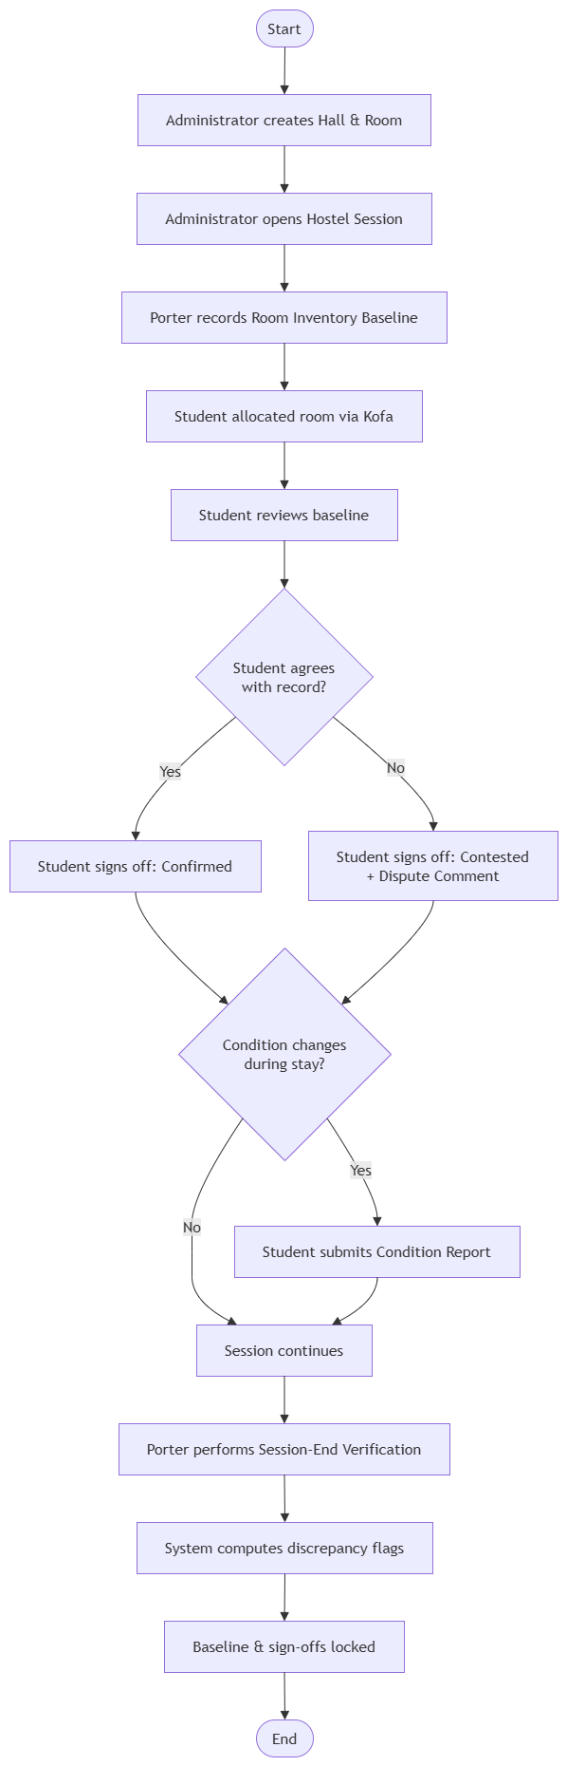
Figure 3.4: Room Lifecycle Activity Diagram
Sequence Diagram
A representative sequence through the system is the Student sign-off flow. The browser first submits a sign-off request comprising the baseline identifier, the sign-off group (corner or shared), a status of confirmed or contested, and, where contested, a required comment to the FastAPI backend. The backend verifies that the requester holds the Student role and owns the allocation the baseline belongs to, checks that the baseline has not already been locked by a prior Session-End Verification, persists the new sign-off record to the database, and finally returns the updated sign-off status to the browser, which updates the Student's room view accordingly.
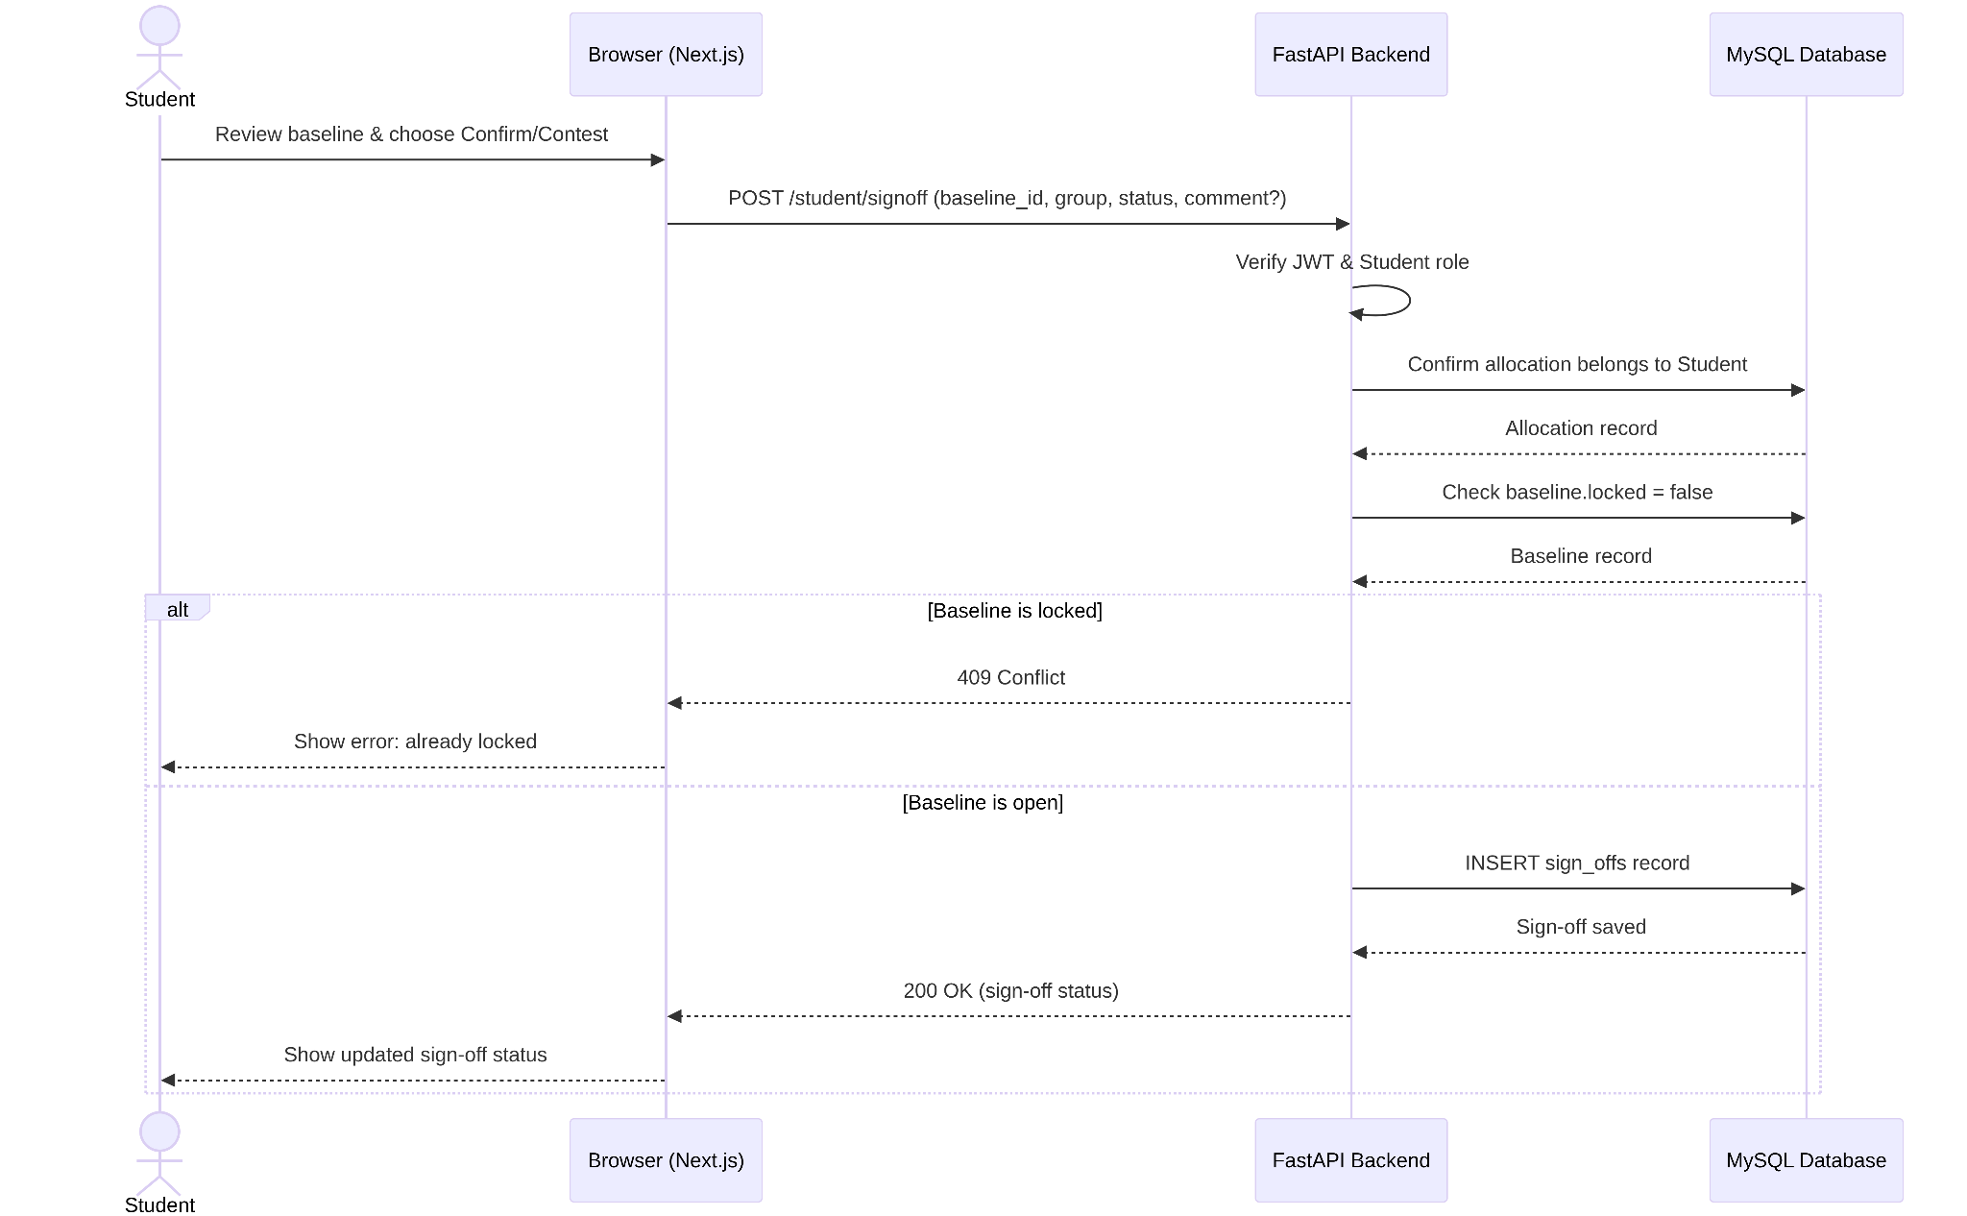Figure 3.5: Student Sign-off Sequence Diagram
Class Diagram
The backend is implemented using SQLAlchemy declarative model classes, one for each of the fifteen tables described in the database design in Section 3.12. Because each model class maps directly, and one-to-one, onto its corresponding database table, the class diagram for the system's domain model corresponds closely to the entity-relationship diagram presented immediately below it; readers are referred to Section 3.12 for the full attribute-level detail of each class.
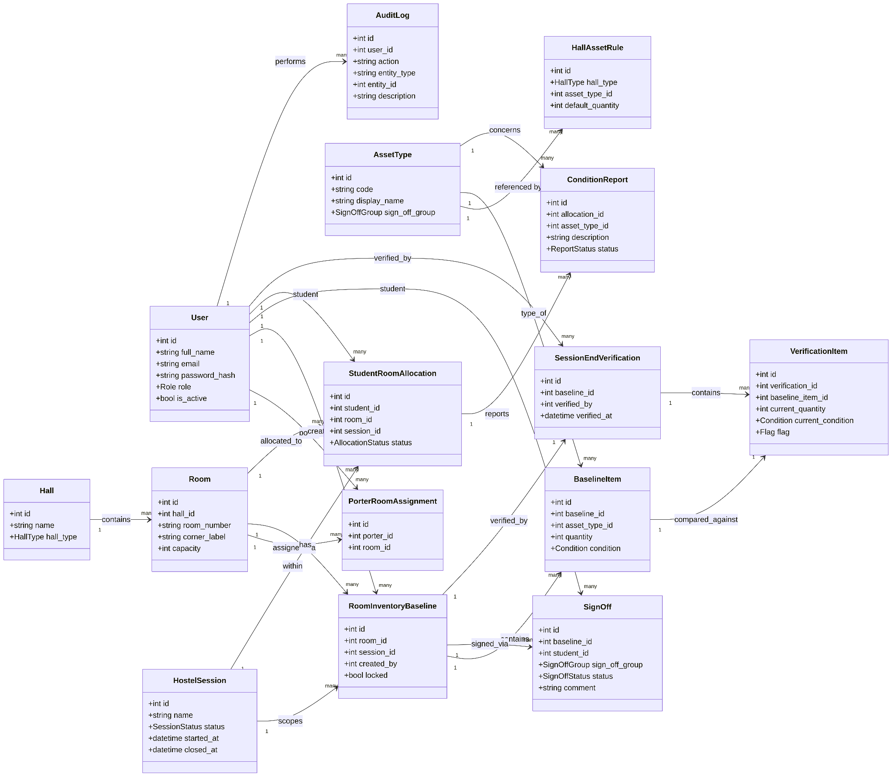Figure 3.6: Domain Model Class Diagram
Entity-Relationship Diagram
The system's core entities are Users, Halls, Rooms, Sessions, Room Inventory Baselines, Baseline Items, Sign-offs, Condition Reports, Session-End Verifications, and Verification Items, together with the supporting reference entities Asset Types, Hall Asset Rules, Porter Room Assignments, and Audit Logs. A Hall has many Rooms; a Room has, across its lifetime, many Room Inventory Baselines, one per session; a Baseline has many Baseline Items and, once verified, exactly one Session-End Verification, which in turn has many Verification Items, one per Baseline Item. A Baseline also has many Sign-offs, one per (student, group) combination for the students allocated to that room. Their full attributes and relationships are detailed in the database design presented in Section 3.12.
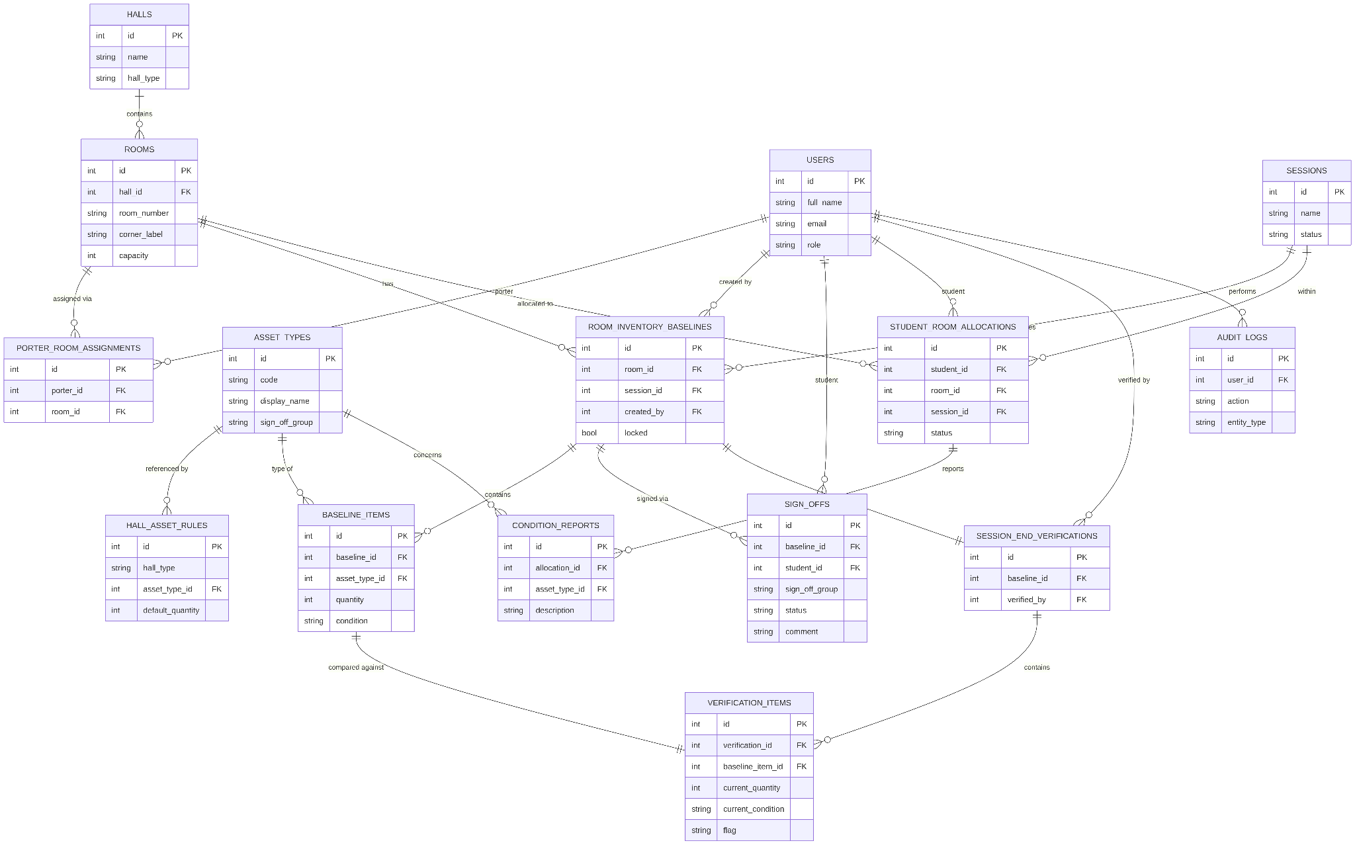Figure 3.7: Entity-Relationship Diagram
Flowchart
The flowchart illustrates the decision logic executed by the system during Session-End Verification to compute the discrepancy flag for each individual asset item, corresponding directly to the algorithm presented in structured form in Section 3.15.
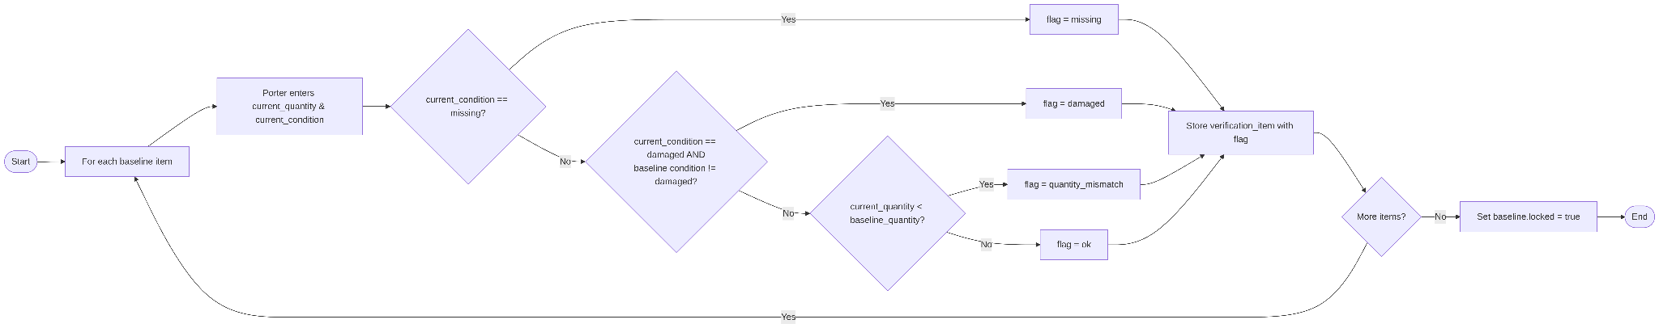Figure 3.8: Session-End Verification Flowchart
Data Flow Diagram
At Level 0, HAPMS is represented as a single process exchanging data with three external entities: the Administrator, the Porter, and the Student and with the underlying data store. 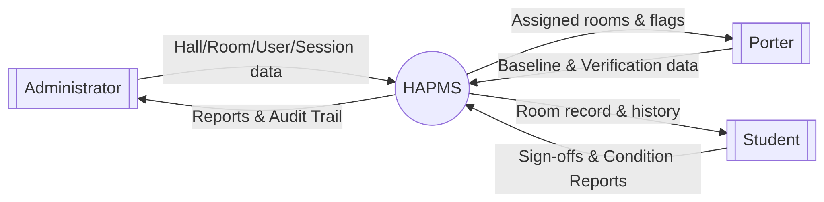Figure 3.9: Data Flow Diagram - Level 0
At Level 1, this single process is decomposed into its major constituent processes: Manage Configuration, Record Baseline, Process Sign-off, Verify Session, and Generate Reports, each of which reads from and writes to the specific tables relevant to it, as described in the database design in Section 3.12.

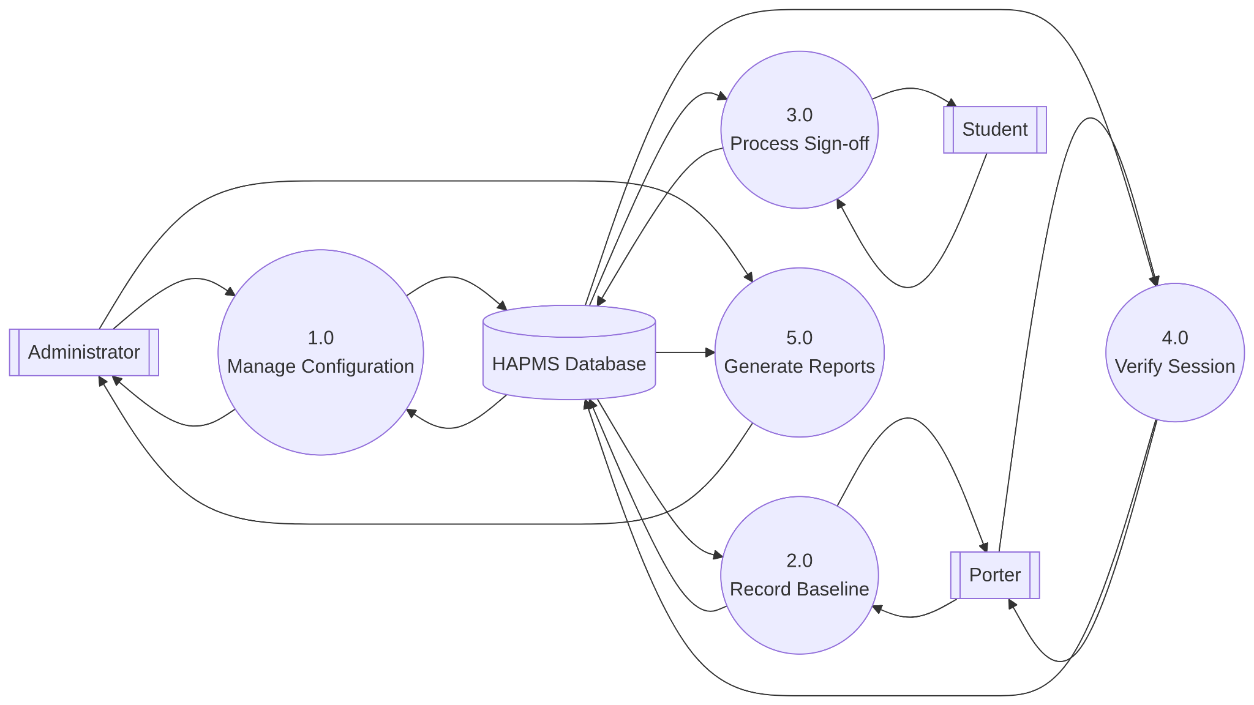Figure 3.10: Data Flow Diagram - Level 1
3.11 Database Design
HAPMS uses a normalised MySQL relational database of fifteen tables each with an auto-incrementing id primary key, indexed foreign keys, and UTC timestamps. The table below summarises the schema.
users : login accounts, role-tagged (admin/porter/student), passwords as bcrypt hashes.
halls / rooms : physical hostel structure; each hall's hall_type drives valid asset types via hall_asset_rules.
porter_room_assignments : links Porters to their assigned rooms.
asset_types : fixed lookup of the eight trackable assets, tagged corner or shared.
sessions : academic hostel sessions, only one active at a time
student_room_allocations : the manual Kofa bridge, linking student to room per session.
room_inventory_baselines : the Porter's initial room record per session; carries the locked flag that freezes it and its sign-offs.
baseline_items : line items (one per asset type) making up a baseline.
sign_offs : one row per baseline/student/group combination, keeping corner and shared sign-offs independent; comment doubles as the dispute note.
condition_reports : optional student-submitted asset-condition updates.
session_end_verifications : one-to-one Porter audit of a baseline.
verification_items :line items per baseline item, each carrying the computed flag from Section 3.15.
audit_log : append only log of every significant action, actor, and timestamp.

Table | Description | Key Fields
users | Every person who can log in. | full_name, email (unique), password_hash, role (admin/porter/student), is_active
halls | A hostel hall/building. | name (unique), hall_type (drives applicable asset rules)
rooms | An individual room within a hall. | hall_id (FK), room_number, corner_label, capacity
porter_room_assignments | Which Porter is responsible for which room. | porter_id (FK users), room_id (FK rooms)
asset_types | The fixed lookup list of trackable asset kinds. | code, display_name, sign_off_group (corner/shared)
hall_asset_rules | Which asset types and default quantities apply to each hall type. | hall_type, asset_type_id (FK), default_quantity, notes
sessions | An academic hostel session. | name (unique), status (active/closed), started_at, closed_at
student_room_allocations | Links a Student to a Room for a Session. | student_id (FK), room_id (FK), session_id (FK), status
room_inventory_baselines | The Porter's baseline record for a room in a session. | room_id (FK), session_id (FK), created_by (FK), locked
baseline_items | Line items of a baseline. | baseline_id (FK), asset_type_id (FK), quantity, condition
sign_offs | A Student's digital sign-off on one grouping of a baseline. | baseline_id (FK), student_id (FK), sign_off_group, status, comment
condition_reports | An optional Student-submitted report of an asset change. | allocation_id (FK), asset_type_id (FK, nullable), description, status
session_end_verifications | The Porter's end-of-session audit for one baseline. | baseline_id (FK, unique), verified_by (FK), verified_at
verification_items | Line items comparing current room state to each baseline item. | verification_id (FK), baseline_item_id (FK), current_quantity, current_condition, flag
audit_log | A chronological activity feed of every action in the system. | user_id (FK), action, entity_type, entity_id, description, created_at

3.12 Input Design
Login Form : shared by all roles; email and password only, with the system routing to the correct dashboard by user role.
Baseline Entry Form (Porter) : pre-filtered to asset types valid for the room's hall type; captures quantity and condition (good/fair/damaged); chair quantity auto-fills to match table quantity.
Sign-off Form (Student) : separate confirm-or-contest choice for corner and shared groupings; contesting requires a mandatory comment.
Condition Report Form (Student) : mandatory free-text description, with an optional asset-type tag.
Session-End Verification Form (Porter) : mirrors the baseline form, populated with existing baseline items; captures current quantity and condition (good/fair/damaged/missing)
Administrator configuration forms : rooms, accounts, porter-room assignments, sessions — all populate selectable options from existing database records rather than free text.

Form | Description
Login Form | Email address and password fields, shared by all roles.
Baseline Entry Form | Presented to the Porter, pre-filtered to only the asset types valid for the room's hall type; each row captures quantity and condition (good/fair/damaged).
Sign-off Form | Presented to the Student for the corner and shared groupings independently; a confirm/contest choice, with a required free-text comment where the student contests.
Condition Report Form | A free-text description field, with an optional asset-type tag.
Session-End Verification Form | Presented to the Porter for each baseline item, capturing the current quantity and current condition (good/fair/damaged/missing).
Administrator Configuration Forms | Forms for creating rooms, user accounts, porter-room assignments, and hostel sessions.

Figure 3.11: Sample Input Forms
3.13 Output Design
Administrator Dashboard : total rooms and flagged issues at a glance, similar to a banking app balance view.
Baseline and Verification Reports : aggregate list views across all halls and sessions.
Audit Trail : reverse chronological log of every action, actor, and timestamp.
Room View / Check-in Slip : Student's baseline for their room, split into corner and shared groupings, with sign-off status.
Session-End Verification Result : Porter-facing flags per item (ok, missing, damaged, quantity-mismatch), computed automatically.

Output | Description
Administrator Dashboard | A summary view showing total rooms on record, total flagged asset issues, and (where enabled) a count of rooms pending sign-off.
Baseline and Verification Reports | List views of recorded baselines and completed verifications across all halls and sessions.
Audit Trail | A reverse-chronological list of every action taken in the system, including the acting user and timestamp.
Room View / Check-in Slip | The Student-facing display of the assets recorded for their room, split into corner and shared groupings, with sign-off status.
Session-End Verification Result | The Porter-facing result of a verification, showing each item's computed flag (ok, missing, damaged, or quantity-mismatch).

Figure 3.12: Sample Output Screens

3.14 Algorithm
This is the system's core logic: computing a discrepancy flag for each asset during Session-End Verification, so a Porter never has to compare baseline against current state by hand. It runs once per baseline line item, and its output combined with the locking step feeds the flagged-issue count on the Administrator dashboard

Algorithm: Session-End Verification Auto-Flagging
- Start.
- For each baseline item recorded against the room's baseline, repeat Steps 3 to 8.
- The Porter enters the item's current quantity and current condition.
- If the current condition is equal to "missing", set the item's flag to "missing".
- Otherwise, if the current condition is equal to "damaged" and the item's original, baseline condition was not already "damaged", set the item's flag to "damaged".
- Otherwise, if the current quantity entered is less than the item's original, baseline quantity, set the item's flag to "quantity_mismatch".
- Otherwise, set the item's flag to "ok".
- Store the verification item, together with its computed flag, against the current Session-End Verification record.
- Once every baseline item has been processed, set the baseline's locked attribute to true, which prevents any further edit to that baseline or to the sign-offs attached to it.
- Stop.
The conditions are evaluated in this order so that more significant discrepancies, such as missing or newly damaged assets, take precedence over quantity differences. Each item receives one final flag.

REFERENCES
Elmasri, R., & Navathe, S. B. (2016). Fundamentals of database systems (7th ed.). Pearson Education.
International Organization for Standardization. (2011). Systems and software engineering — Systems and software Quality Requirements and Evaluation (SQuaRE) — System and software quality models (ISO/IEC 25010:2011).
Norman, D. A. (2013). The design of everyday things (Rev. and expanded ed.). Basic Books.
Pressman, R. S., & Maxim, B. R. (2020). Software engineering: A practitioner's approach (9th ed.). McGraw-Hill Education.
Silberschatz, A., Korth, H. F., & Sudarshan, S. (2020). Database system concepts (7th ed.). McGraw-Hill Education.
Sommerville, I. (2016). Software engineering (10th ed.). Pearson Education.
Wiegers, K., & Beatty, J. (2013). Software requirements (3rd ed.). Microsoft Press.

